
DEPARTMENT OF

COMPUTER SCIENCE & ENGINEERING

Experiment 1
Student Name: Devansh Sharma UID: 23BAI70166
Branch: BE CSE-H (AIML) Section/Group: 23AIT_KRG/ 1
Semester: 6th Date of Performance: 14/01/26
Subject Name: Full Stack - II Subject Code: 23CSH - 382

- Aim:
Modern React Foundations – EcoTrack

- Objective:

• To set up a React project using Vite with proper project structure
• To understand component-based architecture in React
• To apply ES6 array methods (map, filter, reduce) for data-driven UI rendering
• To separate concerns using components, pages, and data modules

- Implementation/Code:

Header.jsx:

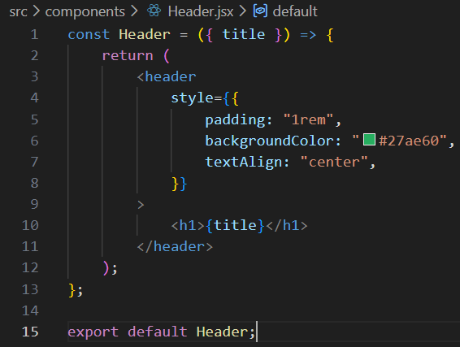

Dashboard.jsx:

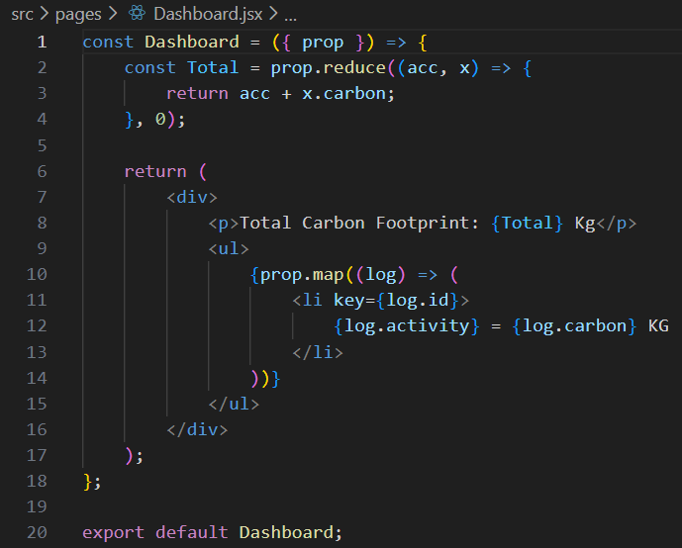

Log.jsx:

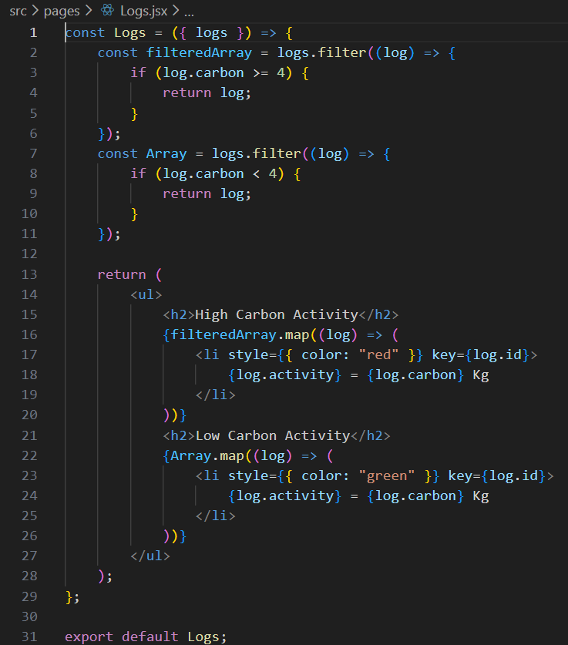

App.jsx:

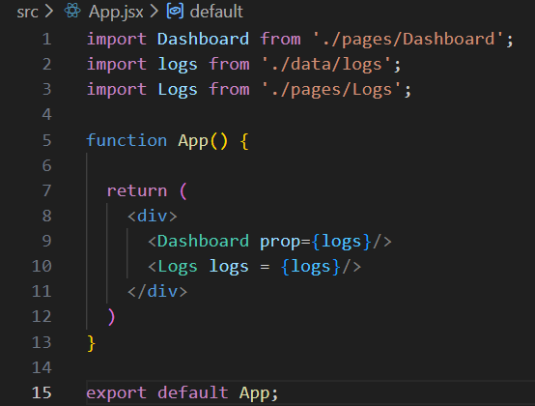

- Output:

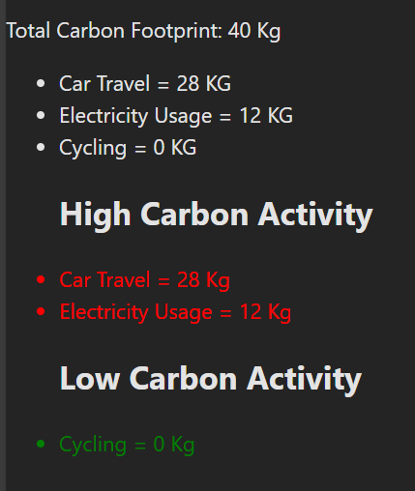

- Learning Outcomes:

- Analyze Project Structure:
Deduce the purpose and architecture of a React application by examining its file and directory organization.
- Component-Based Architecture:
Understand the distinction between page-level components (pages/) and reusable UI components (components/).
- React Router (or equivalent):
(Assuming App.jsx handles routing) Understand how to implement client-side routing to create a single-page application (SPA) feel.
- Data Handling:
Learn how static data can be imported and utilized within React components (as seen with data/logs.js).

